25 Practice Questions
Step 1: Create the t_employee Table
First, let's create the t_employee table with some basic columns.

CREATE TABLE t_employee ( c_eid SERIAL PRIMARY KEY, c_name VARCHAR(50), c_department_id INT, c_salary DECIMAL(10, 2), c_hire_date DATE );

Step 2: Insert Sample Data into t_employee Table

INSERT INTO t_employee (c_name, c_department_id, c_salary, c_hire_date) VALUES
('Alice', 1, 50000, '2020-01-15'),
('Bob', 2, 60000, '2019-03-10'),
('Carol', 3, 45000, '2021-07-23'),
('David', 2, 70000, '2018-05-22'),
('Eve', 4, 55000, '2017-08-19'),
('Frank', 5, 48000, '2019-11-30'),
('Grace', 5, 50000, '2021-01-01'),
('Hannah', 5, 52000, '2020-02-17');

Step 3:Create the t_department Table CREATE TABLE t_department ( c_department_id SERIAL PRIMARY KEY, c_department_name VARCHAR(50) NOT NULL
);

Step 4:Insert Sample Data into t_department
INSERT INTO t_department (c_department_name) VALUES
('HR'),
('Finance'),
('Engineering'),
('Marketing'),
('Sales');

Attempt All Questions are compulsory

- Use of LIKE
Q1. Find all employees whose name starts with 'A'. Q2. Find employees whose names contain 'a'.
SELECT c_name
FROM t_employee
WHERE c_name LIKE 'A%';


- Use of GROUP BY
Q3. Get average salary per department.
SELECT d.c_department_name,
AVG(e.c_salary) AS avg_salary
FROM t_employee e
JOIN t_department d
ON e.c_department_id = d.c_department_id
GROUP BY d.c_department_name
ORDER BY d.c_department_name;
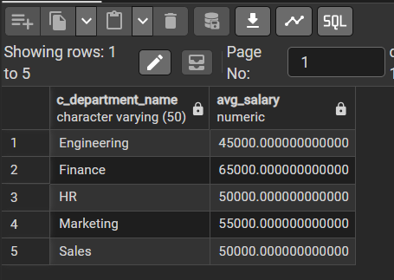

- Use of HAVING Q4. Get departments with more than 1 employee.

SELECT d.c_department_name,
COUNT(e.c_eid) AS total_employees
FROM t_department d
JOIN t_employee e
ON d.c_department_id = e.c_department_id
GROUP BY d.c_department_name
HAVING COUNT(e.c_eid) > 1
ORDER BY total_employees DESC;
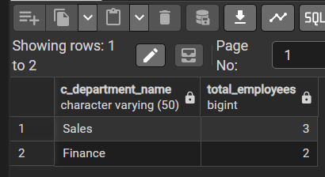

- Use of BETWEEN Q5. Find employees hired between '2019-01-01' and '2020-12-31'.

SELECT c_name,
c_hire_date,
c_salary,
c_department_id
FROM t_employee
WHERE c_hire_date BETWEEN '2019-01-01' AND '2020-12-31'
ORDER BY c_hire_date;
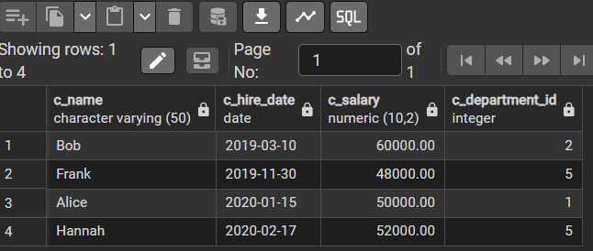

- Use of IN
Q6. List employees in departments 2, 4, or 5.
SELECT c_name,
c_department_id,
c_salary,
c_hire_date
FROM t_employee
WHERE c_department_id IN (2, 4, 5)
ORDER BY c_department_id, c_name;
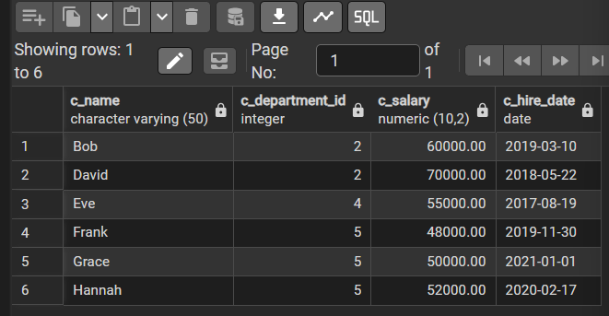

- Use of DISTINCT Q7. Show distinct salaries from employees.
SELECT DISTINCT c_salary
FROM t_employee
ORDER BY c_salary;
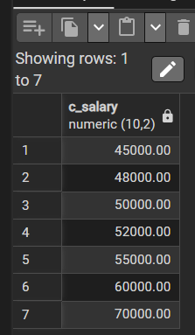

- Use of UNIQUE (on constraint) Q8. Add a constraint to make employee names unique.

ALTER TABLE t_employee
ADD CONSTRAINT unique_employee_name UNIQUE (c_name);


- Use of LIMIT Q9. Get top 3 highest paid employees.

SELECT c_name,
c_salary,
c_department_id,
c_hire_date
FROM t_employee
ORDER BY c_salary DESC
LIMIT 3;
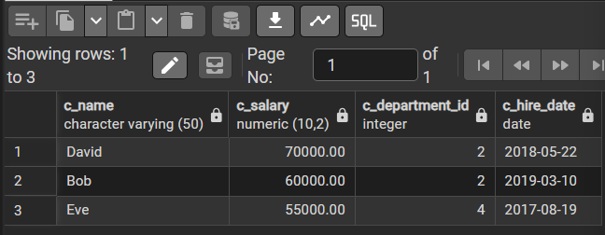

- Use of UPDATE
Q10. Increase salary of 'Alice' by 10%.
UPDATE t_employee
SET c_salary = c_salary * 1.10
WHERE c_name = 'Alice';


- Use of INSERT
Q11. Add a new employee named 'Ivy'.
INSERT INTO t_employee (c_name, c_department_id, c_salary, c_hire_date)
VALUES ('Ivy', 3, 47000, '2022-09-12');
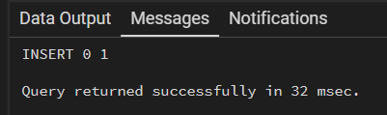

- Use of ALTER
Q12. Add a new column for job title.
ALTER TABLE t_employee
ADD COLUMN c_job_title VARCHAR(50);
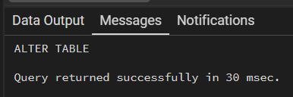

- Use of ALIAS
Q13. Display employee name as "Employee Name".
SELECT c_name AS "Employee Name"
FROM t_employee;
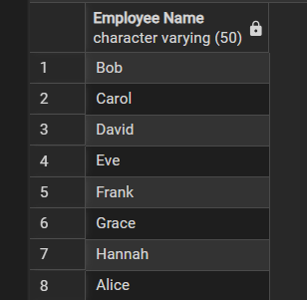
Q14. Get department name and employee count using join and alias.
SELECT d.c_department_name AS "Department Name",
COUNT(e.c_eid) AS "Employee Count"
FROM t_department d
JOIN t_employee e
ON d.c_department_id = e.c_department_id
GROUP BY d.c_department_name
ORDER BY "Employee Count" DESC;
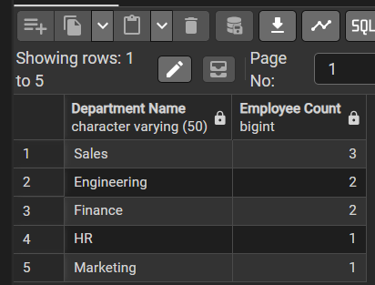

- Combine Concepts
Q15. Get names of employees with salary between 48000 and 60000. Q16. Get departments with total salary > 100000.

SELECT c_name AS "Employee Name",
c_salary AS "Salary"
FROM t_employee
WHERE c_salary BETWEEN 48000 AND 60000
ORDER BY c_salary;
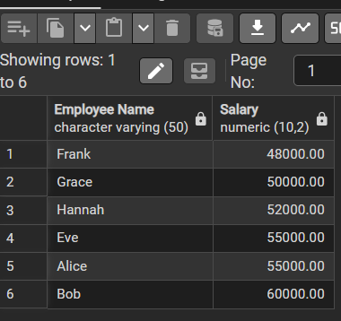

Q17. List distinct departments employees belong to.
SELECT DISTINCT d.c_department_name AS "Department Name"
FROM t_employee e
JOIN t_department d
ON e.c_department_id = d.c_department_id
ORDER BY d.c_department_name;
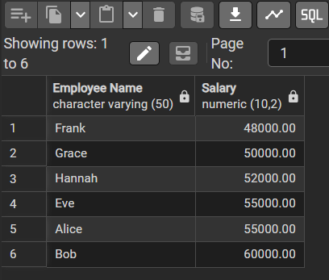
Q18. Find all employees with names ending in 'e'.

SELECT c_name
FROM t_employee
WHERE c_name LIKE '%e';
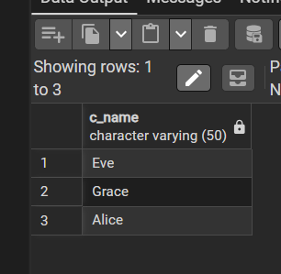
Q19. Show employees with job title NULL.
SELECT c_name,
c_department_id,
c_salary,
c_hire_date,
c_job_title
FROM t_employee
WHERE c_job_title IS NULL;
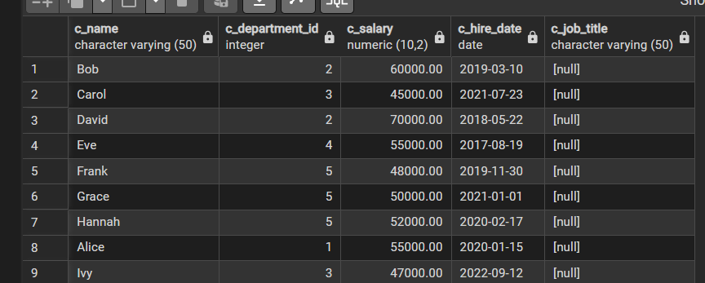
Q20. Rename column c_name to full_name.
ALTER TABLE t_employee
RENAME COLUMN c_name TO full_name;
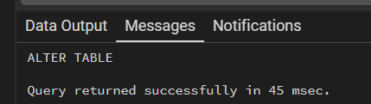
Q21. Find average salary for departments with more than 1 employee.
SELECT d.c_department_name AS "Department Name",
AVG(e.c_salary) AS "Average Salary",
COUNT(e.c_eid) AS "Employee Count"
FROM t_department d
JOIN t_employee e
ON d.c_department_id = e.c_department_id
GROUP BY d.c_department_name
HAVING COUNT(e.c_eid) > 1
ORDER BY "Average Salary" DESC;

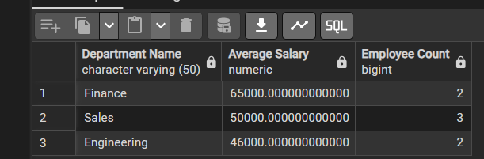

Q22. Get top 5 recently hired employees.
SELECT full_name,
c_department_id,
c_salary,
c_hire_date
FROM t_employee
ORDER BY c_hire_date DESC
LIMIT 5;
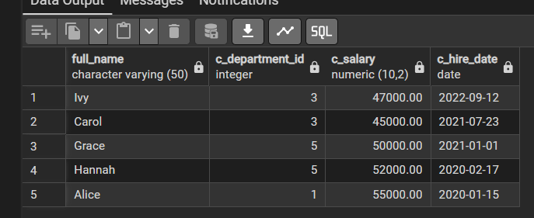

Q23. Insert employee with job title.
INSERT INTO t_employee (full_name, c_department_id, c_salary, c_hire_date, c_job_title)
VALUES ('John Doe', 2, 58000, '2023-04-10', 'Software Engineer');
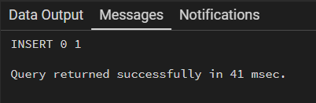
Q24. List all employees with salary not in (45000, 50000).
SELECT full_name,
c_department_id,
c_salary,
c_hire_date,
c_job_title
FROM t_employee
WHERE c_salary NOT IN (45000, 50000)
ORDER BY c_salary;
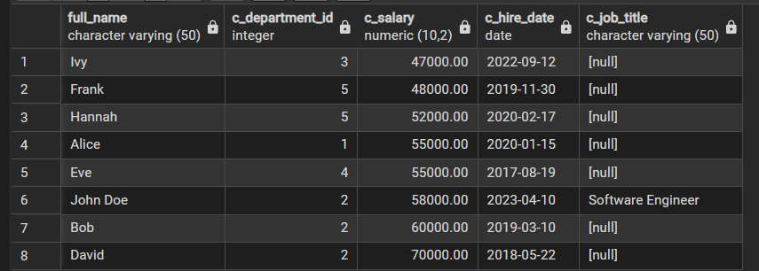

Q25. Find employees whose name is either 'Alice', 'Eve', or 'Grace'.
SELECT full_name,
c_department_id,
c_salary,
c_hire_date,
c_job_title
FROM t_employee
WHERE full_name IN ('Alice', 'Eve', 'Grace');
